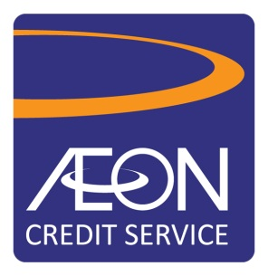

Functional Specification Document (FSD)
EXPRESS CARD REBRANDING
PERSONAL FINANCING

DOCUMENT CONTROL

Version: 1.0
Release Date:

Distribution List:

Name | Role | Department
Cheang Lai Yan | PMO | ITG
Adrian Tan | Working committee | ITG
Coniex Goh | Working committee | ITG
Angie Ng | Working committee | PD
Nikkie Lam | Working committee | VF
Mohd Nooraizal | Working committee | CAG
Heston | Working committee | GEP

Versioning Control
Version 1.0 is the first version release to the project stakeholders. This is for review and input by all project stakeholders. At the end of this review process version 1.0 will be created for base lining. Base lining will occur as a result of the document sign off being achieved.

Version | Date | Comment
1.0 |  | New

Confidentiality

This document contains proprietary information that is confidential to AEON Credit Service (M) BHD. Disclosure of this document in full or in part, may result in material damage to AEON Credit Service (M) BHD. Written permission must be obtained from AEON Credit Service (M) BHD prior to the disclosure of this document to third party
Table of Contents

1.0 Introduction 4
1.1 Background 4
1.2 Purpose & Objective 4
1.3 Existing Challenges 4
1.4 Definitions of Acronyms & Abbreviations 5
2.0 Functional Requirement 6
3.0 Personal Financing Application 16
4.0 Personal Financing Application Screens / Figure 20
5.0 Sign off statement 36

Introduction
The AEON Express Card was introduced by AEON Credit Service (M) Berhad in 1998 with the intention to reward the good payment customers with exclusive services including special EP & PF loan rate & faster approval process.

With the new proposed AEON Express Plus Card, we will leverage on the AEON Member Plus Card’s platform and rebrand the current Express Card. We aim to take this opportunity to enhance the overall benefits of the new card. Plus, to streamline the EP application and approval process to provide a better customer experience to the cardholder through seamless application.

1.1 Background
The AEON Express Card was introduced in 1998, since then we have approximately 1.68 million member base up to date. 36% of the members are active as of February 2017 (those who have taken loan and still serving the instalment). Based on the percentage of active members, it shows that there is a huge potential of this base for repeat customers on our EP & PF sales. Hence, we would like to leverage on AEON Member Plus Card’s platform to rebrand the current Express Card.

1.2 Purpose & Objective
- Enhance customer and merchant experience with “Convenient, Smart and Fast” concept – the financing application processes will be simplified to minimize customer’s effort, zero bureaucracy and prompt application results;
- Maximize sales via Database Marketing – focusing on the essence of database marketing which enable us to target and communicate the relevant product to the right target segments will help us to maximize sales captured under each customer
- Gain customer loyalty – the refreshed approach will provide more convenience to customer on loan application, hence it will create or increase customer stickiness towards our products & company;
- Reduce operating cost and time – the technology intervention would reduce the human dependency, thus will help on reduction of headcount expenses and TAT;
- Product synergy – contribute to the growth of AEON Member Plus business;
- Maintain competitive advantage – to optimize the advantages of business relationships with thousands of merchants nationwide, which will be conveniently reached by customer to purchase their desired products; and
- Preserve environment – the technology intervention subsequently would help to reduce the paper usage i.e. paperless operation from the implementation of e-form and e-agreement.

1.3 Existing Challenges
- Overall application turnaround time
  - Normal 2nd loan application & above, the processing turnaround time still required to take approximate of 4 days from customer walk in to merchant until customer collect the product.
- Customer Verification Process
  - There will be cases where CAG officers unable to contact customers for verification, hence this will caused delay on the application process.
- Express Card Issuance
  - No ownership for Express Card Issuance condition.
  - Lack of market awareness due to the card features.
  - Limited card features. i.e. fast processing with finance amount capping and Low interest/profit rate

1.4 Definitions of Acronyms & Abbreviations

Terms | Descriptions
CPR | Credit Policy
GEP | General Easy Payment
MEP | Motor Easy Payment
PF | Personal Financing
EP | Easy Payment
ITG | Information Technology Group
CAG | Credit Assessment Group
ACS | AEON Credit Service
ACSM | AEON Credit Service Malaysia
BAU | Business as usual
QR code | Quick Response Code
SMS | Short Messaging Service
CCD | Call Centre Department

Functional Requirement
No. | Requirement | Feedback
3.1 | Duplication of full Prepaid Card function  - ITG to duplicate the list of functions from AEON Member Plus Prepaid Visa Card with BIN# 410709 to the following BIN#.  - BIN Number: 528199 (current existing Prepaid MasterCard’s BIN)  - System to differentiate existing Prepaid MasterCard range Non-Contactless (5281-9901) and new AEON Member Plus Card (Express)-Contactless with a different card range (5281-9902) within the same BIN.  - Card product with BIN# 5281-9902 will have the following function:  - List of functions of prepaid card as per the following list duplicating from BIN# 410709 (except for Visa related functions as the card will be on MasterCard platform)  Module of duplication includes:  - PIN Issuance/ Pin Change/ Set Pin  - Card Replacement  - Point Rebate & Point Expiry  - Top Up  - All Fees & Charges except for Annual Fee  - Card Termination  - Refund  - Statement of Account  - Inquiry and other services via AEON Website  - Customer Information Update  - Authorization  - Fraud Control  Rewards Structure  Point Earning:  - This card will not be getting any rewards points for retail spending unless specified in the future ( do not hardcode that no rewards points earn. Make it open as moving forward we might open for rewards points earning for spend)  - This card will reward customer based on every RM1= 2 rewards points on their monthly instalment amount (principal + interest amount) for prompt payment-refer to the following current Payment Pattern table (do not hardcode, rewards points number might change in the future)  Payment Pattern Table (Reward based on all the following payment pattern code-prompt payment):  - Points earned will be credited to customer account by end of the day on daily basis based on PMS batch run.  - Only full payment with the above code status will be rewarded with points (partial payment will not be eligible for points)  Rewards points will only be rewarded to customers if:  - Payment pattern code: I, X, a, A, b & B only when they make payment.  - Make Prompt payment with full installment amount of the month. Data field to captured for points rewards will be P+I on monthly basis only (advance payment exceeded the monthly P+I amount will not be rewarded with points until the next month if customer settled full prompt payment- Refer to Scenario 1)  - For customers who make full early settlement, rewards points will also be credited to them based on the full settlement amount (Refer to Scenario 2).  - Rewards points will be rewarded based on agreement based and not by IC based.  Scenario Table 1: Monthly Installment RM200. Not rewarding customer for advance payment  Scenario Table 2: Monthly Installment-RM200, 12 months tenure. Full Early Settlement  Rewards Redemption to Cash Rebate (as per BAU)  i) Min. conversion set at 1,000 points & subsequently in denomination of 200 points.  ii) Customer is allowed to perform partial redemption as above denomination.  iii) If rebate amount were to exceed the purse limit, system to reject the request and prompt error message.  iv) Point rebate request will be credited to customer account on the next day.  v) Point expiry -3 years from the year points have been accumulated (e.g. reward points earned from August  2016 to December 2016 is considered reward points earned in year 2016 and will therefore expire on 31st December 2019.  Fees & Charges - Annual Fee  - No annual fee will be charged to customer. No not hardcode this. In the future, management might decide to charge annual  - This card to be MasterCard PayPass enabled (contactless function).  - Every card will have a One-off Limit tag to each account for customer to apply GEP, MEP or PF loan.  - The following info will be available in customer inquiry screen for viewing purposes.  - Total One-off limit assigned  - Used limit  - Available limit  - To link AEON Member Plus Card (Express) with the products (GEP, MEP & PF) that customer apply from One-off Limit. This is to ease CCD for customer inquiry.  - The One-off Limit tagging also will be applicable for current AEON Member Plus Card Visa Paywave and future E-money card.  - To ensure all the requirement will be available in CRM also.
  Initial Payment | Before Last Month End | After Last Month End-2nd | 3rd-5th
  I | X | a | b
  Autopay |  | A | B
   | Jan | Feb | Mar | Apr | May | June
  Payment | Pay on 2nd, RM200 | Pay on 18th , RM200 | Pay on 2nd – RM300 | Pay on 2nd  – RM100 | Pay on 2nd- RM300 | Request refund for RM100 as original instalment is RM200
  Points Rewarded | 400 points | 0 point | 400 points | 400 points (since this month RM100 + last month advance payment = RM200) | 400 points
   | Jan | Feb | Mar | Apr | May
  Payment | Pay on 2nd  -RM200 | Pay on 18th  -RM200 | No Payment | Pay on 2nd for only one month & status still in D1 | Full settlement  RM1800-principal+ interest & late payment charges
  Points Rewarded | 400 points | 0 point | 0 point | 0 point | RM1600 X 2= 3200 points
3.2 | Generation of Eligible Listing (Detailed & Final criteria pending CAG & CPR to share)  ITG to generate the eligible listing based on the following criteria shared by CPR (same as one-off limit management)  - Active Express Card Customers who are active for the past 12 months (any of the month). Active means customers who are still serving their loan instalment with us.  - Inactive Express Card Customers who are principal credit cardholders with current status active with no delinquency status.  1) One Time Conversion Exercise Plan –from existing eligible Express Card base  i)E-mail & SMS  Eligible customer listing* to be divided by communication channels: E-mail OR SMS (Customers who have email address, we will blast e-mail. For customers who does not have any email address registered with us, we will blast SMS)  A website hyperlink will be included in the E-mail & SMS. Customers will need to click into the link and land on our current website login page. For customer who does not have an web account with us, they need to register an account through this page before proceeding to accept the card. For customer who already have an account with us, they need to login to accept the new AEON Member Plus Card (Express). After click on accept button, customer will be able to see the mailing address & e-mail address registered with us for their confirmation. If mailing address or e-mail address is not the updated one, customer will be able to update their mailing address or e-mail address on the same landing page before they click ‘Update to the above information & send the card to me’. Refer to Figure 37-40.  System needs to auto capture the list of customers who have accepted the card on daily basis for PD to do card embossing and arrange sending the card to customers. (refer to item 3.3)  ii)Telemarketing  After 14 days from the E-mail and SMS blast date, system to auto generate the list of customers who did not respond/ accept the card by sending the list of contact numbers to telemarketing (CRM system) for calling.  Telemarketing will update the status of “accept” or “reject” in the system if customer accept the card offer. Telemarketer is also required to re-confirm the mailing address & e-mail address registered with us and confirms that that is the correct address for us to send the card and future information to customer. If customer would like to change mailing address or e-mail address, telemarketer to update in the system/form.  If status update as “accept”, system will auto capture the list of customers on daily basis for PD to proceed with card embossing. (refer to item 3.3). If customer decline the offer, “reject” status will be updated accordingly to the system.  Once customer accepted the card through either SMS, E-mail or Telemarketing, an E-mail or SMS will be sent to them summarizing the key features of the card and inform them that by default the card is online/e-commerce and overseas transaction disabled. To enable the function, they can do it via ACS website or by calling our Call Centre.  To ensure all the requirement will be available in CRM also.  2) New Eligible Customer  i) Eligible listing will follow existing AEON Prepaid MasterCard issuance. Refer to the following Capturing of Embossing Data section for New customers  *Dedupe against existing AEON Member Plus Visa Prepaid Cardholders. For customer who has the AEON Member Plus Visa Prepaid Card, system only need to tag customer an Express Card status and a SMS will auto trigger blast to customer to inform that he/she is eligible for the Express card status to enjoy special approval process and special rate.
3.3 | Capturing of embossing data  Existing Express Card Member  After customer accepted the offered card at our ACS webpage or through our Telemarketing agent, system shall auto proceed with the following:-  - Duplicate the Master CIF to E-money account. Mandatory fields as below. (without new address provided by customer upon card acceptance)  - Duplicate the Master CIF to E-money account. Mandatory fields as below. (with new address provided by customer upon card acceptance)  - Generate data and capture into the daily embossing file to vendor. Emboss data file name should be separated as “AEON Member Plus Express” for easy reference.  - Embossing data will be auto delivered to card vendor via SFTP. (BAU process)  - Card will be delivered to customer home address, therefore, card collection indicator will default as “home”.  - Card will be delivered by registered mail (AR) via POS Malaysia.  - Auto issue PIN mailer. (PIN mailer printing process remain unchanged as per BAU process)  - Embossing file to be updated in card logistic system for tracking purposes as per current BAU process.  - Update embossing historical in AS400 as per current BAU process.  - Include the card type of “AEON Member Plus Card” to “Delivery note” and “Daily embossing report”. (Refer to report requirements).  New Customer (to replace the existing Express card issuance process)  - System to auto generate the embossing data for eligible customer according to the criteria set by CPR.  - Emboss data file name should be separated as “AEON Member Plus Express” for easy reference.  - Embossing data will be auto delivered to card vendor via SFTP. (BAU process)  - Duplicate the Master CIF to E-money account after embossing data generated. Mandatory fields as below:-  - Card will be delivered to customer home address, therefore, card collection indicator will default as “home”.  - Card will be delivered by registered mail (AR) via POS Malaysia.  - Auto issue PIN mailer. (PIN mailer printing process remain unchanged as per BAU process)  - Embossing file to be updated in card logistic system for tracking purposes as per current BAU process.  - Update embossing historical in AS400 as per current BAU process.  - Include the card type of “AEON Member Plus Card” to “Delivery note” and “Daily embossing report”. (Refer to report requirements). | CRM
  - Title  - Full name as per IC & IC number  - Date of Birth  - Gender  - Nationality  - Race  - Marital status | - Home Address (existing)  - Mobile number  - Email address  - Home number  - Office number  - Occupation  - Gross salary
  - Title  - Full name as per IC & IC number  - Date of Birth  - Gender  - Nationality  - Race  - Marital status | - Home Address (New)  - Mobile number  - Email address  - Home number  - Office number  - Occupation  - Gross salary
  - Title  - Full name as per IC & IC number  - Date of Birth  - Gender  - Nationality  - Race  - Marital status | - Home Address  - Mobile number  - Email address  - Home number  - Office number  - Occupation  - Gross salary
3.4 | Card activation  Card activation is to follow current credit card process. After card embossed, card send status should be tagged as “embossed”. Customer is request to activate their card through our ACS Web, IVR, SMS or CCD.  To ensure the entire requirement will be available in CRM also.
3.5 | Return Card (BAU process)  Return card process remain unchanged. All the card return will be tagged as “return” in current card logistic system. The list of return card will be shared with Retention unit by weekly basis to follow up with customer (BAU process).
3.6 | PIN Issuance / Change PIN / Set PIN (as per BAU process)  - Pre-printed PIN is sealed and sent separately after the card embossed.  - Customers can perform PIN change or Set PIN at the following channels:  - Cash Deposit Machine (CDM)  Customer needs to insert card into CDM and key-in PIN mailer password for PIN change.  - Website  Customer has to login to ACSM web and will receive OTP for Set PIN request.  - EDC terminal  PIN change also applicable at EDC Terminal.  - If customer forgotten their PIN, they can log-in to ACS web or call in to CCD to request for PIN re-issue which follow the current credit card and Prepaid MasterCard process.  - To ensure all the requirement will be available in CRM also.
3.9 | CAG Assessment (Refer CAG FSD as per attached)
3.10 | Cancellation  - Cancel after application submitted through ACSM Web/ACSM apps, and before loan is approved. (Refer to Figure 9)  - There will be a button for customer to cancel the application if customer wishes to during the application on the loan processing page.  - Once customer clicks on the CANCAL APPLICATION button, we will reconfirm again if customer really wish to cancel the application. YES or NO, PLEASE CONTINUE WITH THE APPLICATION.  - For customer who chooses YES, page will show that LOAN APPLICATION HAS BEEN DISCONTINUED. For customer who chooses NO, page will direct customer back to the loan processing page.  - Cancel after application is Approved  - There will be a CANCEL LOAN button on the VIEW APPROVED LOAN page. Once customer click on this button, we will reconfirm again if customer really wish to cancel the pre-approved loan. Selections with YES or NO (Refer to Figure 12)  - Once customer clicks YES, status will be changed to CANCELLED immediately. If customer clicks NO, everything will remain the same on the VIEW APPROVED LOAN page.  - Once cancellation accepted, AS400/ LOS need to capture the cancellation and reflect in the system, ACSM web and ACSM apps.

Personal Financing Application
Log in / Start Up page
    - Customer to log into ACSM Web or ACSM Mobile Apps to apply for PF loan.
    - From the product listing, customer can see AEON Member plus card (Express) – Refer to Figure 1.
    - Click SELECT AN ACTION, customer will be able to see an option of APPLY FOR A LOAN – Refer to Figure 2.
    - Under APPLY FOR LOAN page, customer will be able to select which loan type they would like to apply – Refer to Figure 3: Apply for “Personal Financing”.
E-Application & Approval
    - Customer to input Loan Amount (free text-every RM1, 000. MIN RM1, 000 - MAX RM100, 000) & Loan Tenure (6-84 months). System need to prompt error message if tenure that customer input does not match the eligible tenure selections.
    - Once customer enter financing amount & the loan tenure (Refer Figure 4), the table on the left will show the tenure (months) available and calculated monthly repayment amount (RM). For tenure that is not available for the customer, monthly repayment column will be shaded in grey. (Refer Figure Table 1)
    - Customer is required to input their Disbursement Account details (Refer Figure 4).
(Copy of account statement / passbook to be submitted during S&P Signing at CSU).
    - Customer is required to upload the Latest income documents (based on latest CPR requirement / guideline). (Refer to Figure 5)
    - A notification has to be prompt for Customer to confirm their details in “My Info” page (Refer Figure 4). The details to confirm are: -
        - Mobile Number
        - Home Address
        - Employment Address
        - Email Address
    - Customer is required to fill up min information required in e-Auto debit form in webpage. Eg: (Refer to Figure 7)
  - Full name as per IC.
  - NRIC no.
Table 1: Tenure & Repayment Table for different scenario based on customer’s financing amount.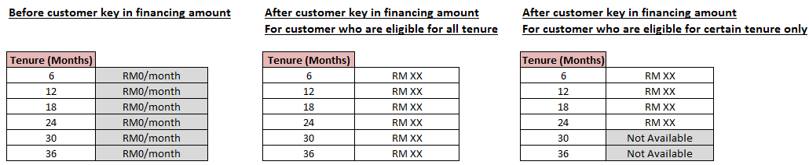
Note: These tables are for illustration purposes only. Vendor/Agency need to propose the appropriate design and layout.
    - Once submitted, a notification on Acknowledgement of submission is displayed to customer in the webpage. Together a link for customer to view the Application status “View Approved Loan” page. Also “Cancel Application” button is also available on the same page (Figure 9).
    - Submitted e- Application is route to CAG for processing (Refer to Figure 9).
    - Approved / Reject cases a notification will be send to customer via SMS or Email.
    - Summary on Approved Loan is showed (Figure 11) , details :
- Application date (DD MM YY)
- Status : Approved / Decline
- Approved Date : (DD MM YY)
- Approved Loan Amount : RM Xx
- Approved Loan Tenure: Xx months.
- Monthly Instalment amount (RM Xx).
- Codes Expiry : DD MM YY
- Agreement No. : Eg. (822 XXXXX XX)
- Button for Cancellation “Cancel Loan”.
    - Approved Agreement the first 3 digit Agreement number (822) will remain unchanged as per current practice to identify “Express Card” customer.

Fill up e -Auto debit form (Figure 7)
    - Customer will able to edit/ input the complete details in e-auto debit form via the link provided in email, once the Loan is approved. Or should be able to input at CSU during Signing S&P.
    - It is a MANDATORY requirement for customer to do the followings before Customer Sign the S&P Agreement: -
        - Enter Full details in e-Auto Debit Form: Customer Name, NRIC, Auto Debit Bank Name, Account Type, Account No., and Customer Mobile No.
    - The e- Auto Debit Form is to be reflecting in AS400 (Megaform) Auto Debit Template (Refer Figure 14).
    - The complete e-auto debit form with T&C to be generated by AS400 & printed at CSU by CSU staff and customer to provide Signature & submit the Original form to CSU staff (Refer to Figure 14).
S&P Agreement & Product Disclosure Sheet
    - S&P Agreement and Product Disclosure Sheet is generate as per BAU process at CSU. Customer Signed S&P once walk-in to CSU.
Disbursement
    - Upon completion of Sale & Purchase Agreement, CSU staffs should proceed for “Sale Confirmation” as per current practise.
    - The loan amount <RM10,000 to be disbursed into Customer’s e-money card.
    - For Loan Amount >RM 10,000, it has to trigger Finance to TT the balance (minus RM10, 000) to customer's bank account (follow BAU process) upon CSU perform Sales Confirmation.
Stamping process
As per existing BAU process.
Reports in BU storage file & AS400.
- A New channel code is required to identify all the loan applications submit from the existing customer base. This channel code which tagged to the agreement will be reflected in AS400, MOS, Sales Claim system, LOS and CRM.
- Daily E-Money Express Card PF Sales Report by channels (website, mobile application).
- Daily disbursement report via E-Money card is auto generate with Customer’s Name, NRIC, Card No., & Agreement No. on daily basis and available in BU storage.
- Daily disbursement report via TT by Finance department is auto generate with Customer’s Name, NRIC, Card No., & Agreement No. on daily basis and available in BU storage.
- Application transaction & amount by product (GEP, MEP, PF) with status pending, pre-approved, approved.

Personal Financing Application Screens / Figure

Figure 1: Add AEON Member Plus Card (Express) as one of the new card type
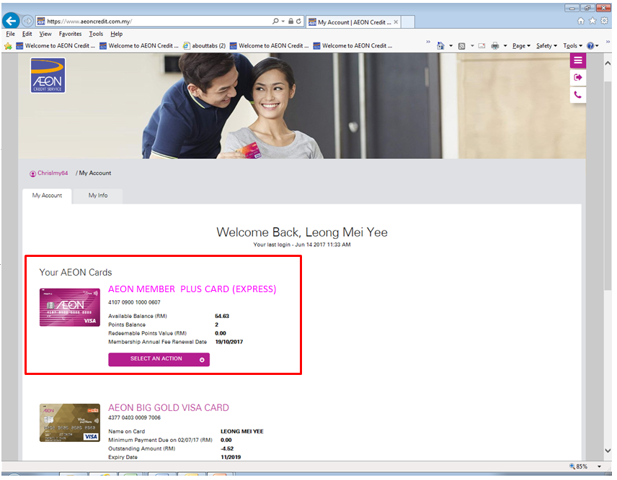

Figure 2: Include 2 additional fields under ‘SELECT AN ACTION’
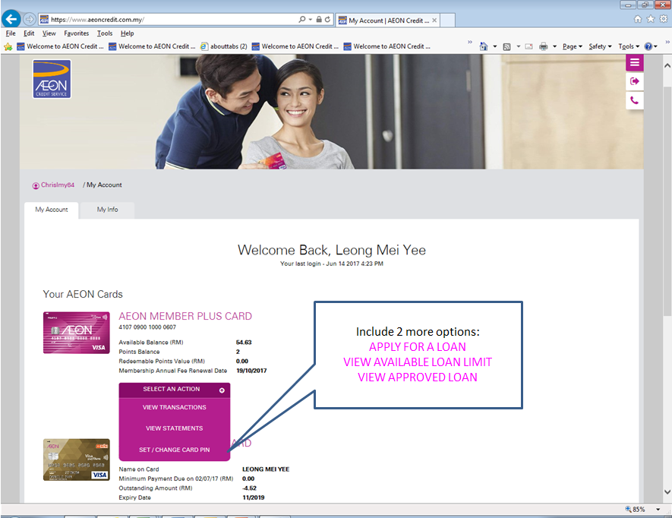

Figure 3: Page for customer to select loan type (Select : PERSONAL FINANCING)
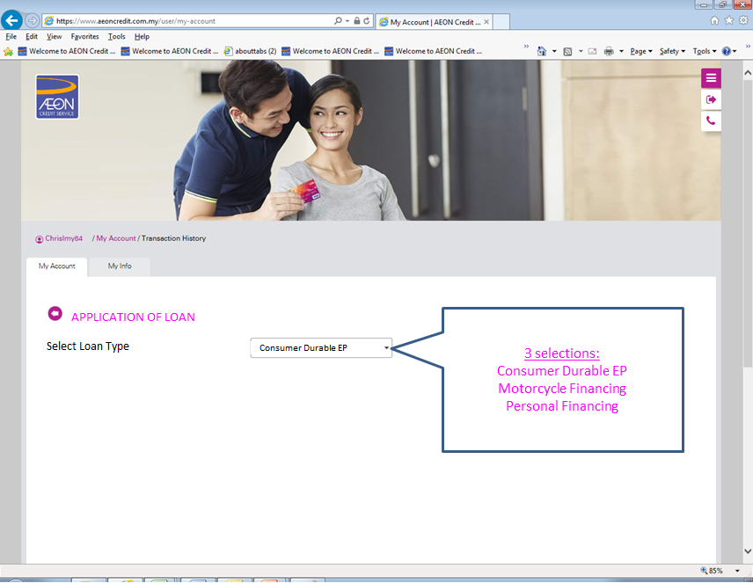

Figure 4: Application Form for Products PERSONAL FINANCING
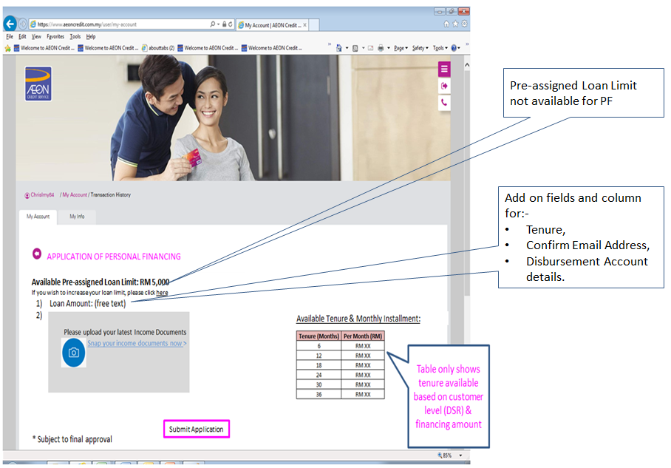
A notification has to be prompt for Customer to confirm their details in “My Info” page.

Figure 5: Upload Documents Page
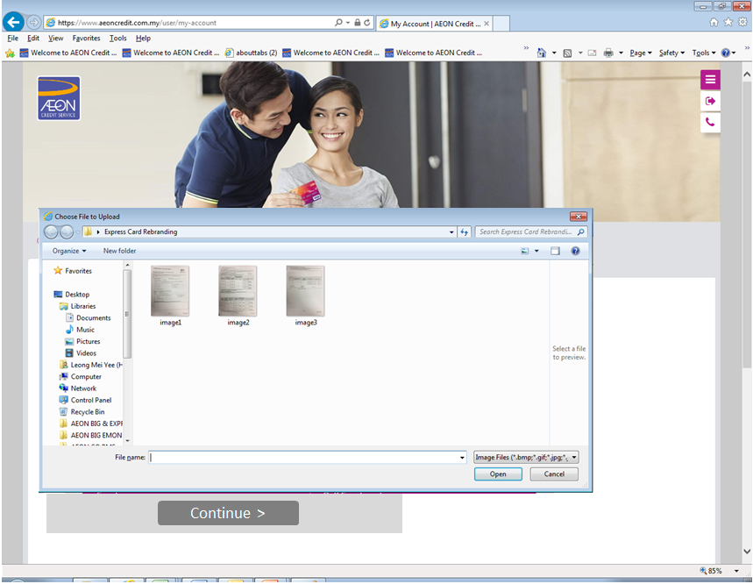
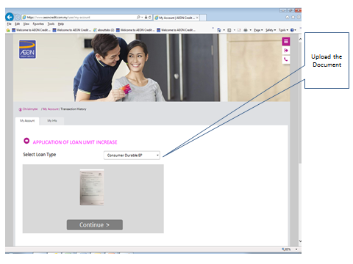
Figure 6: Complete of upload documents
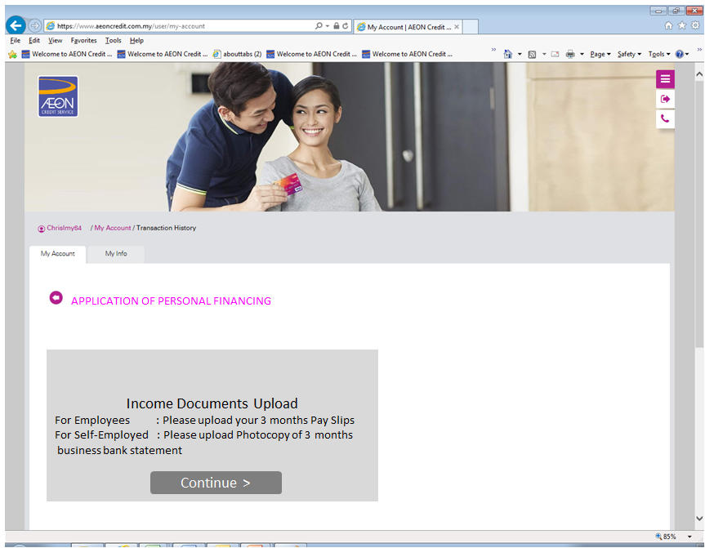

Figure 7: Page for customer to input Auto debit details
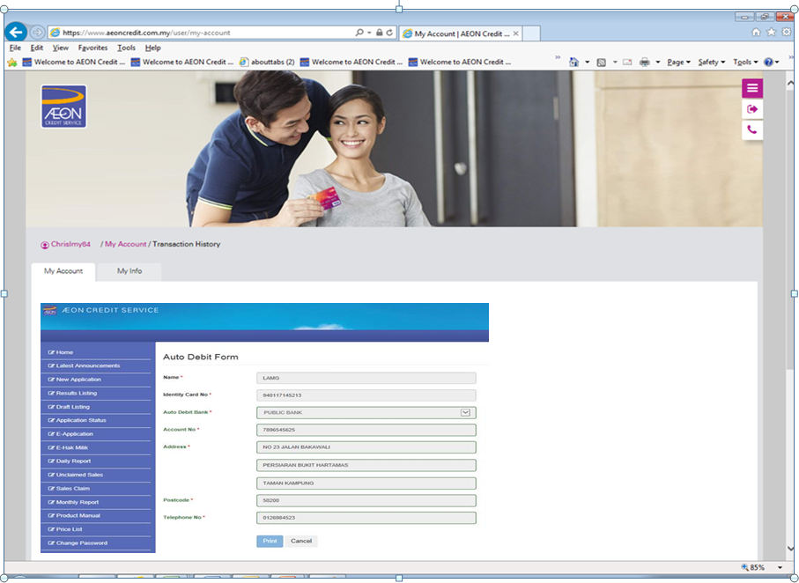
e- Auto Debit to be generated in Auto Debit template in AS400 once customer complete fill up the form.
Customer required to Sign the complete Auto Debit form which generated in AS400 (Refer figure 14) during customer walk in to branch to Sign the S&P Agreement.
Figure 8: Application Submission Page
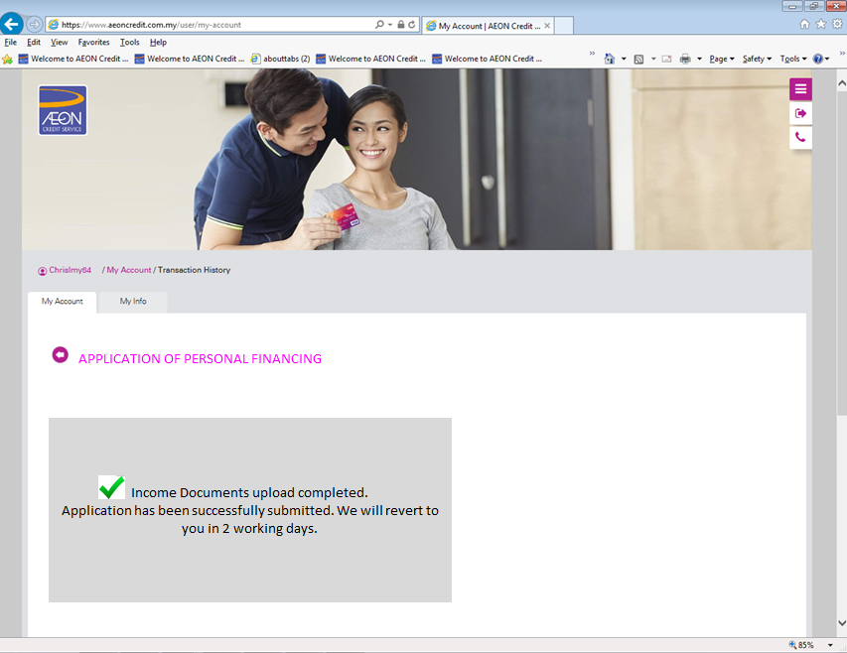

Figure 9: Processing Page: For PF Application
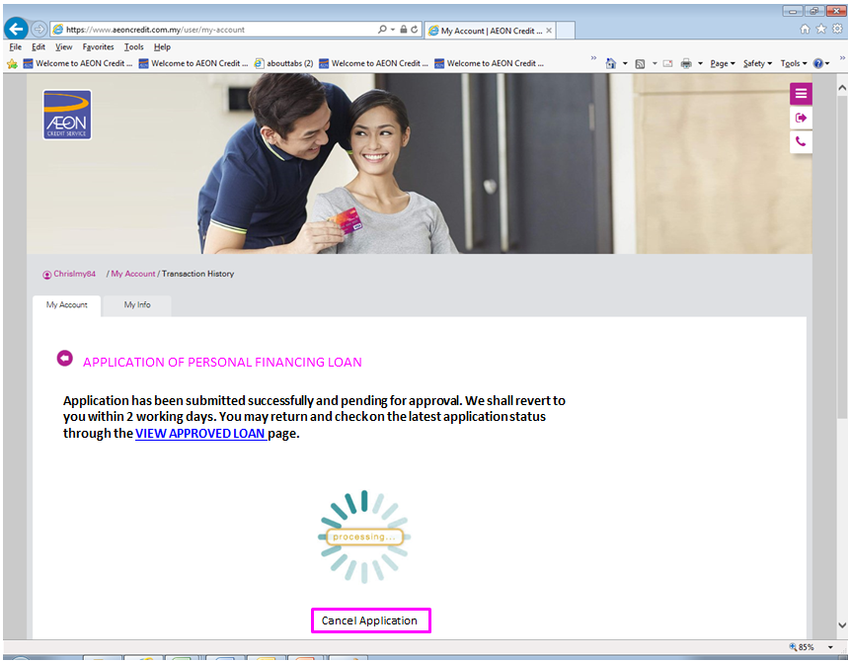

Figure 10: Loan Declined Page
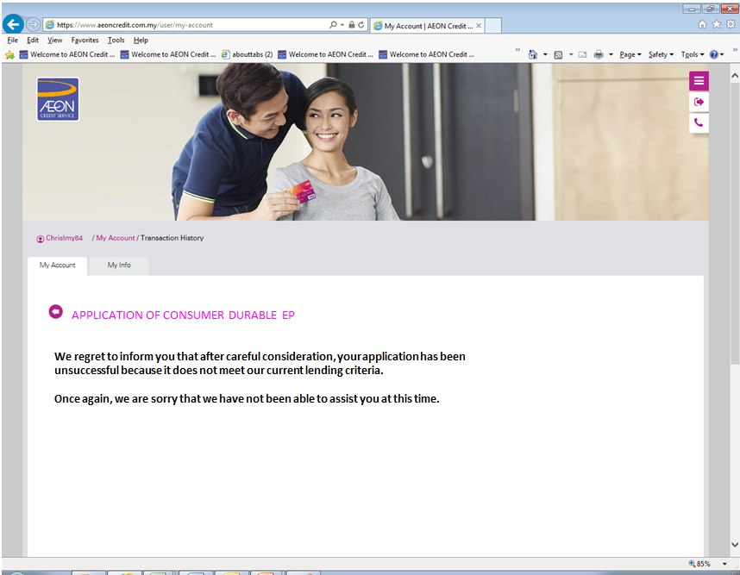
Available for Personal Financing

Figure 11: VIEW APPROVED LOAN FOR PERSONAL FINANCING
Include the information as per below:
- Application date (DD MM YY)
- Status : Approved / Decline
- Approved Date : (DD MM YY)
- Approved Loan Amount : RM Xx
- Approved Loan Tenure: Xx months.
- Monthly Instalment amount (RM Xx).
- Agreement No. : Eg. (822 XXXXX XX)
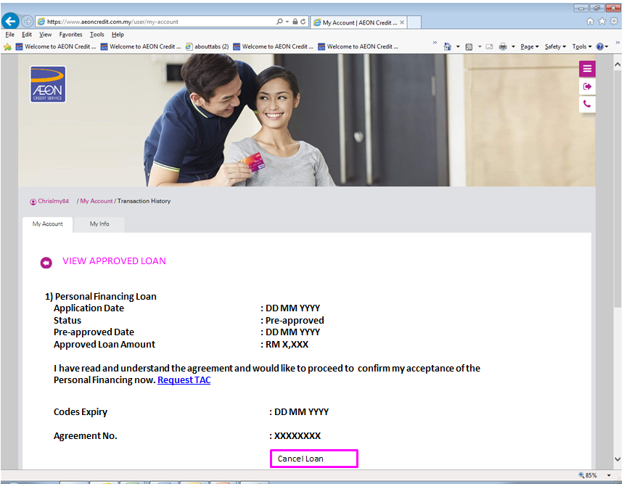
Include additional Message to require customer to walk-in to CSU/ branch to Signed S&P Agreement and Auto Debit form.
Add on a link to for customer complete the e-Auto debit form (Figure 7)

Code Expiry & TAC is not applicable for PF (to be removed)

Figure 12: IF customer clicks “Cancel Loan” Button under View Approved Loan
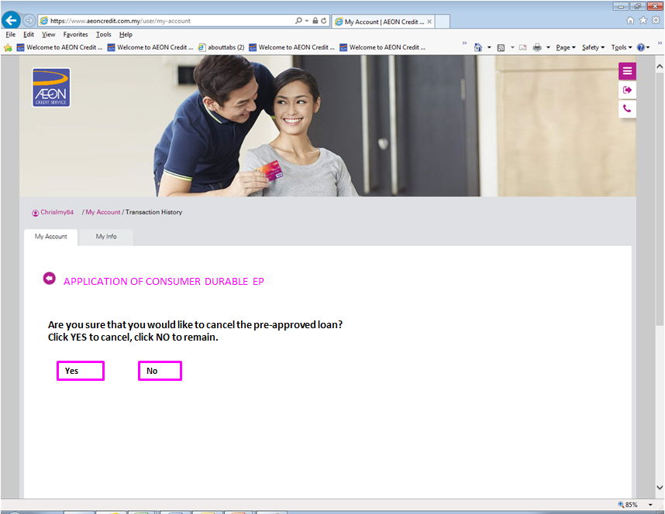

Figure 13: Declarations by customer
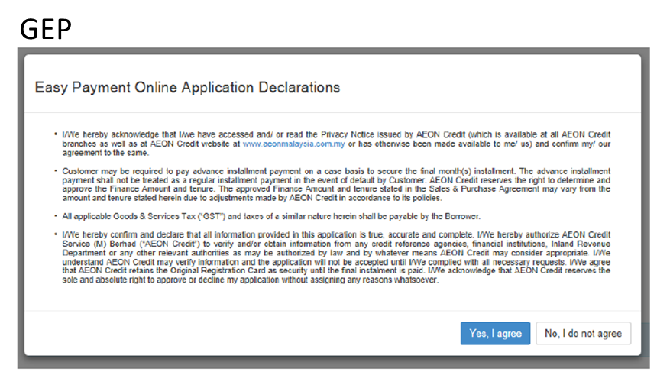
Provide declaration page for PF as per existing PF online application.

Figure 14: Auto Debit Template generate in AS400 from Megaform

Sign off statement

Prepared / Compiled by:
Name: K. Sarvindran Nair  Position: Sen. Officer  Date: 15/09/2017 | Name: Leong Mei Yee  Position: Manager  Date: | Name: Angie Ng Position: Manager  Date:
Name:
Position:
Date:
Concurred by:
Name: Veronica Sebastian  Position: HOD (PF)  Date: | Name: Wong Hooi Theng  Position: HOG  Date: | Name: Lai Fung Suk  Position:  Date:
Approved by:
Name: Hau Kok Peck  Position: HOG  Date: | Name: Tan Kean Wooi  Position: Deputy Div Head  Date: | Name:  Position:  Date:

